**Working With Dataset**

|  |  |
| --- | --- |
| Team Member Name | Marisakthi.G |
| Team ID | PNT2022TMID23401 |
| Project Name | A new hint to transportation - Analysis of the NYC bike share system |

# Loading Dataset:

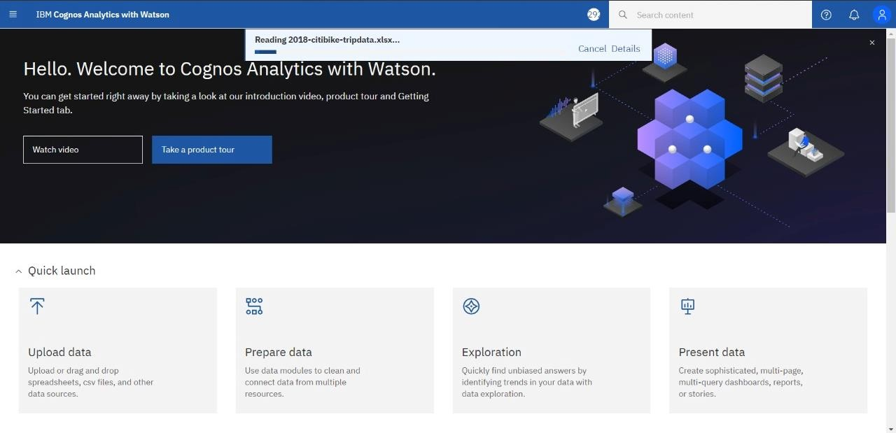

**Understanding Dataset:**

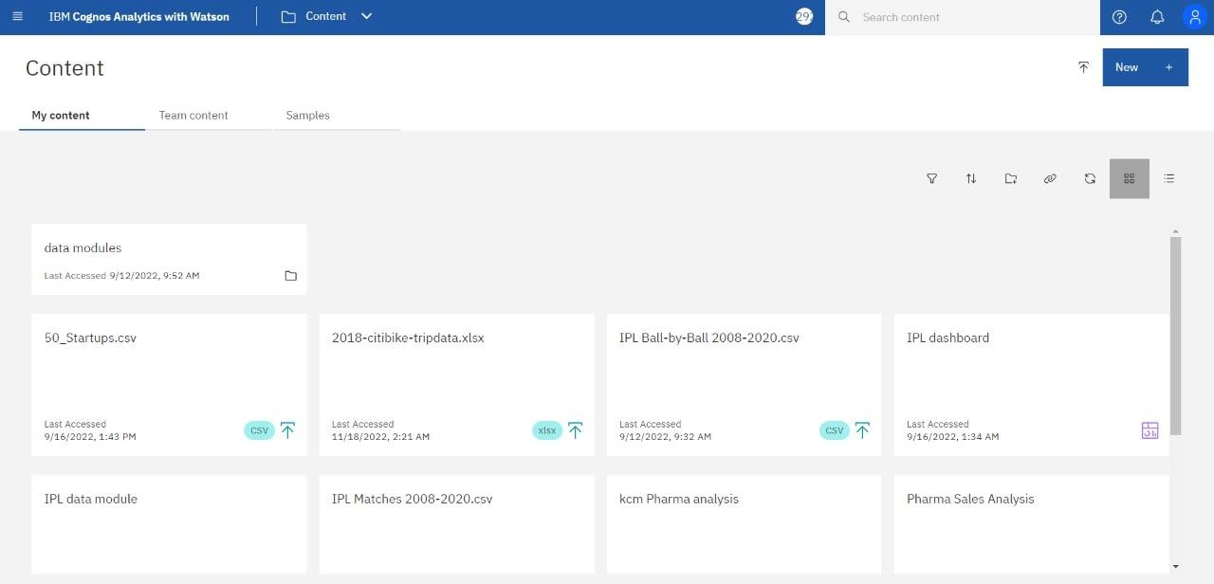

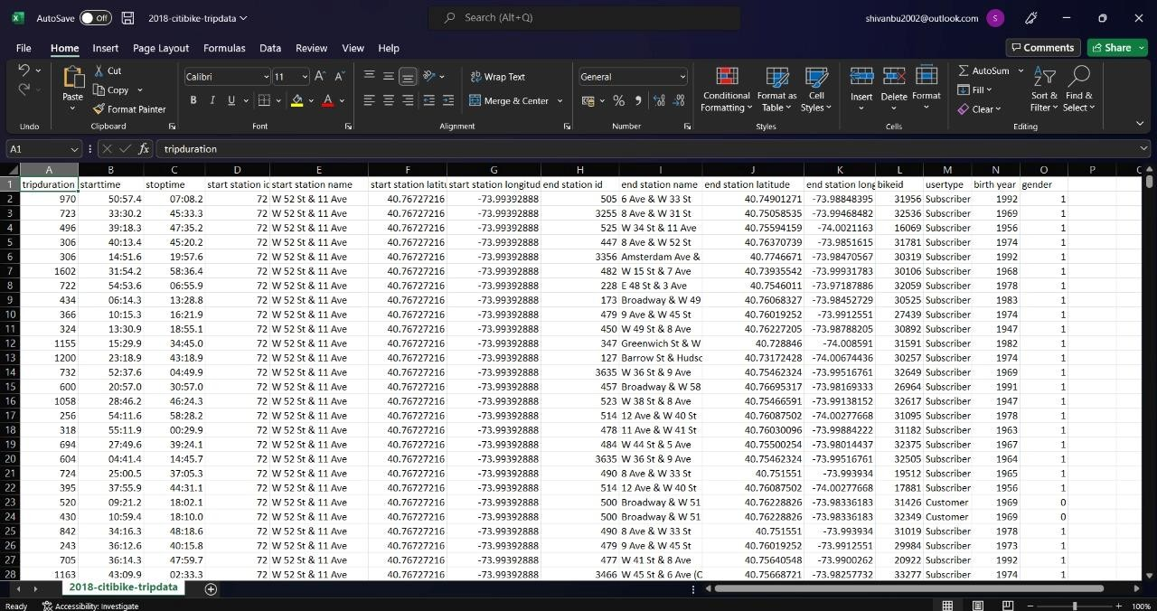

1. Trip Duration (seconds) — How long a trip lasted
2. Start Time and Date
3. Stop Time and Date
4. Start Station Name
5. End Station Name
6. Station ID - Unique identifier for each station
7. Station Lat/Long - Coordinates
8. Bike ID - unique identifier for each bike
9. User Type (Customer = 24-hour pass or 3-day pass user; Subscriber = Annual Member) - Customers are usually tourists, subscribers are usually NYC residents
10. Year of Birth - Self-entered, not validated by an ID.
11. Gender (Zero=unknown; 1=male; 2=female) - Usually unknown for customers since they often sign up at a kiosk

# Exploration of Dataset:



